Microsoft Outlook: Set up for laptops or desktops
Official URL: https://services.smsu.edu/TDClient/180/Portal/KB/Article/3991/Microsoft-Outlook-Set-up-for-laptops-or-desktops
Category: Knowledge Base > Information Technology Services > Software and Applications > Microsoft Outlook: Set up for laptops or desktops
Tags: microsoft, email, outlook
_____________________________________________________

How to Setup Microsoft Outlook on laptops or desktops
- Find and open your Outlook Application, this can be done by using the search function or by finding it in your application list
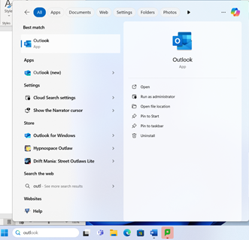
Figure 1: Screenshot
- The first time you open outlook a welcome screen will pop up, type in your your email address using the format StarID@go.minnstate.edu (students) or StarID@minnstate.edu (faculty/staff) and click continue
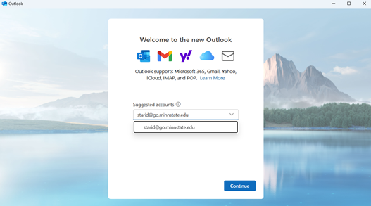
Figure 2: Screenshot
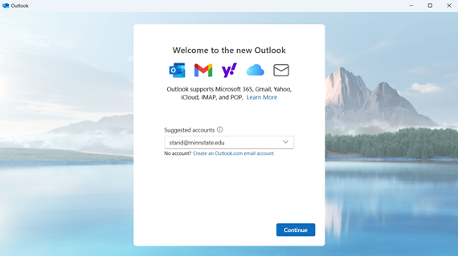
Figure 3: Screenshot
- You will be redirected to a second sign in page where you will need to type your starid@go.minnstate.edu or starid@minnstate.edu and enter your password. Then select sign in.
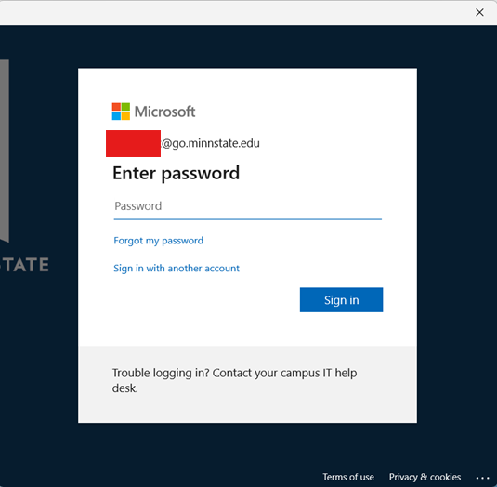
Figure 4: Screenshot
- If you have Multi-Factor Authentication set up follow the prompts on your screen
- After that your account should be set up!
If you are having any difficulty setting your email up, please contact the Technology Resource Center Helpdesk by e-mail at TRC@smsu.edu or by phone at 507 537 6111.

Additional Resources
Shared Mailbox
For more information on how to add and access shared mailboxes please follow the instructions in this link.
Mail Forwarding
For more information on how to set up mail forwarding please follow the instructions in this link.

Accessibility Review & Update Log:
- [ ] Content accuracy verified
- [ ] Color contrast checked
- [x] Image alt-text verified (screenshots auto-captioned)
- [x] Document structure and headings formatted (perfect bold, list bulletpoints and sequences preserved)

